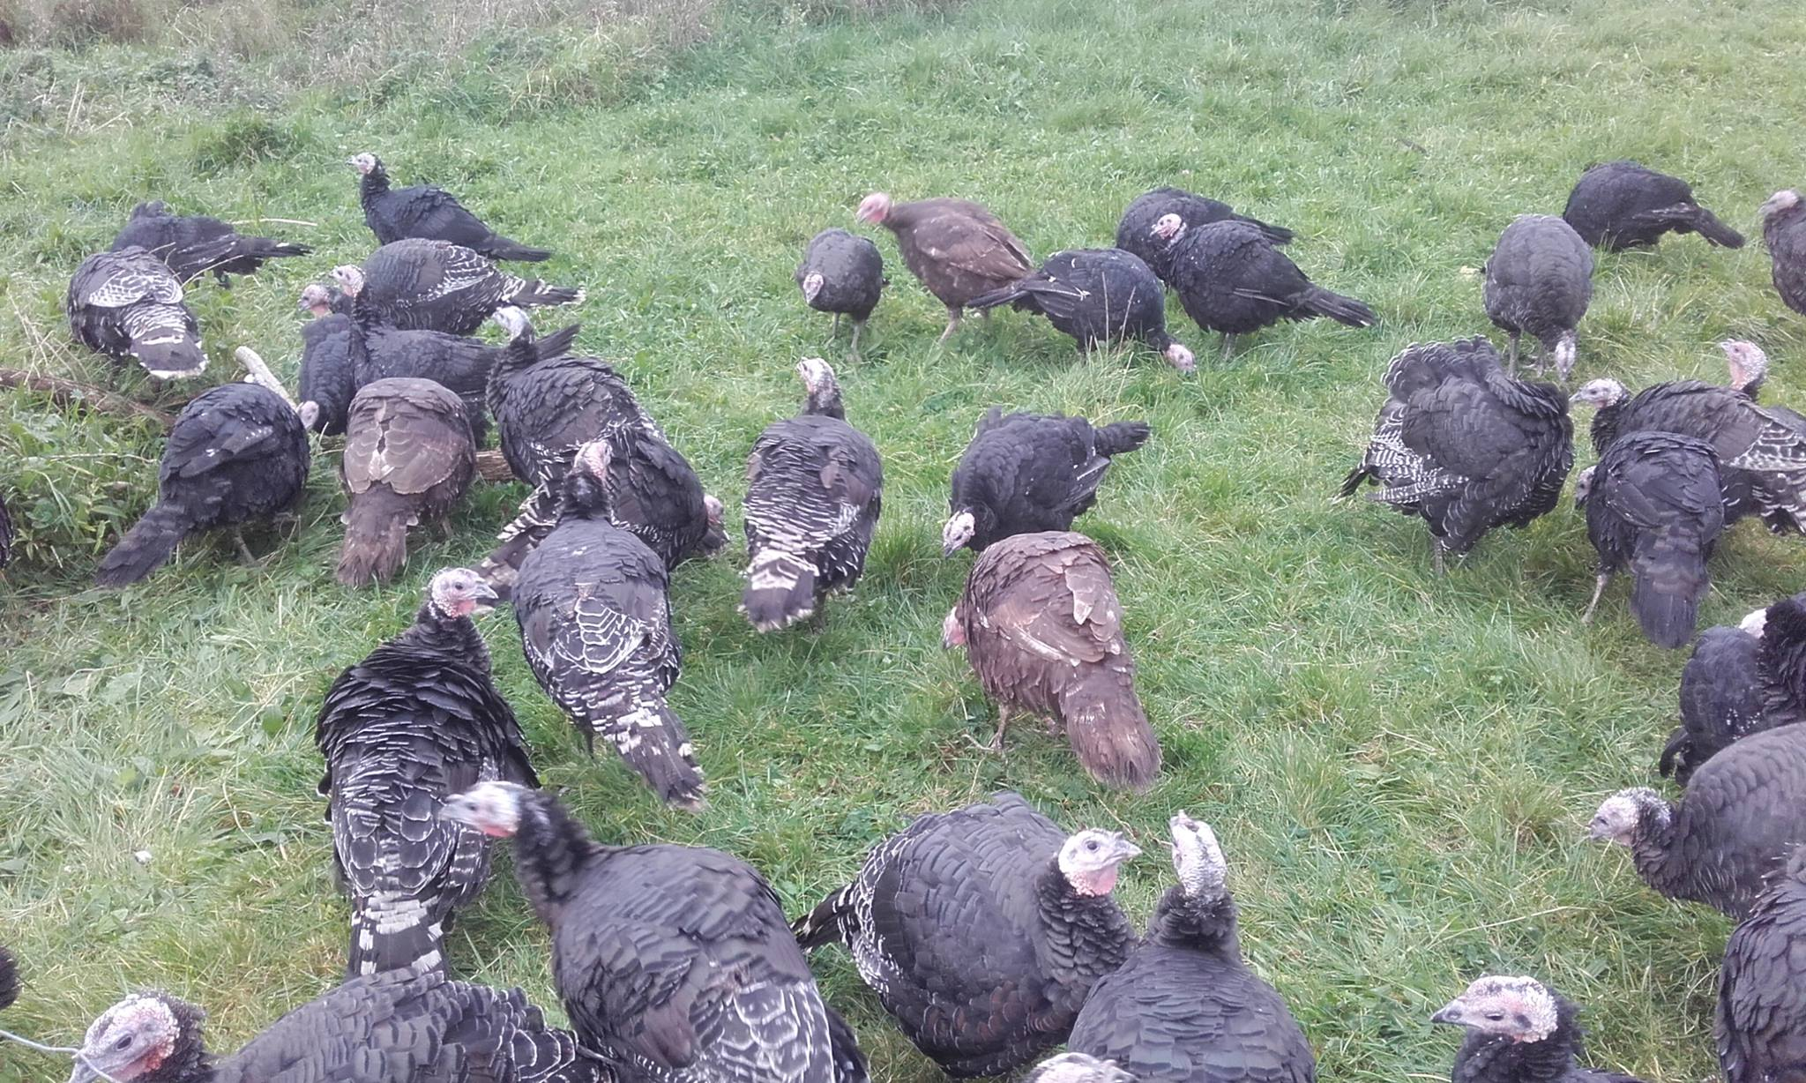
Organic Oven ready Norfolk Black and Bronze Turkeys.

The turkeys have been foraging on a diet of grasses, wild herbs, kale, potatoes, cabbage, nettles, clover, organic meal and apples over the last 6 months to produce a succulent fine textured meat that will provide a Christmas dinner experience that your friends and family will not forget.
We take great pride in our turkeys and rear them to a very high standard and once humanely slaughtered, our turkeys are carefully hand plucked and hung for five days to enhance their wonderful flavour.

Our oven ready turkeys will range in weight from 5 kg to 9kg and are priced
at €13.00 per kg.
Giblets are included.
Contact: Laurie 0873329322 or westernshoreorganicfarm@yahoo.ie

